**PROPOSAL FOR**

**DESIGN, SUPPLY, INSTALLATION, TESTING AND COMMISSIONING OF 97 KWp GRID-TIED SOLAR ROOF TOP POWER PLANT**

**Submitted**

**To**

**J.T Fabrics-Madurai**

**By**



**(AN ISO 9001-2015 & 14001-2015 CERTIFIED COMPANY)**

# 

# GREENTEK INDIA PRIVATE LIMITED

**Plot # 8, Lepakshi colony, West Marredpally, Secunderabad -500026**

**Tel: 040-27807145 / 040-65198519, Mob: +91-90031 32081**

**E-mail:projects@greentekindia.co.in, www.greentekindia.co.in**

**Introduction, Vision & Mission of Greentek India Pvt Ltd**

GIPL is an ISO 9001:2015 & 14001-2015 certified Company based at Hyderabad is one of the leading manufacturers of Solar Photo Voltaic Modules (SPV) in the Country. We are manufacturing modules in the range of 37W to 300W. Thus, our Module production line is geared to produce panels of any custom size or wattage having Certifications/Approvals from MNRE, IEC 61215, IEC 61701, IEC 61730.

GIPL is having strong presence in the field of Renewable Energy and provides complete turnkey solar EPC solutions. We have a team of highly skilled solar engineers to design and construct you solar project. GIPL offers Advisory Services, Engineering, Procurement & Construction (EPC) Services and Operation & Maintenance Services Solar Power Projects ranges KWp to MWp scale to domestic, industrial, commercial and government entities.

Incorporated in the year 2007 and expertise in all renewable energy systems. Joint ventured with many reputed companies throughout the India and having the best technical partners and supplier in their class throughout India.

To become one of the leading renewable energy equipments and turnkey solution provider. We always aim at one step ahead in the development of innovative and competitive solutions for the production and management of electrical power through Solar PV systems. Served & serving many esteemed organizations and individuals in India.

**Solar Photovoltaic:**

 * Grid connected or Utility scale Solar Power Projects.

 * Off-grid SPV Power Packs.

 * Rooftop Solar Power Projects (Standalone & Grid-tied).

 * Other Solar application

GIPL is a registered Solar PV Systems integrator in MNRE, NREDCAP & TNREDC.

GIPL tries not just to meet our customer’s expectations; strive to exceed the customer’s expectations. Every time, measure its success by its customer’s trust and confidence in us. We always work with principle to provide up to date technology, the best quality equipment, error less workmanship and on time service to its clients.

**Manufacturing Facility:**

**State of the art manufacturing facility at Shabhashpally(V), Shivampet(M), Medak(Dt) at a distance of 60 k.m from Hyderabad.**

1. **Solar PV modules**
   1. **Polycrystalline**
   2. **Monocrystalline**
2. **Solar Water Heaters**
   1. **Flat Plate Collector (FPC)**
   2. **Evacuated Tube Collector (ETC)**

**Corporate Office: Plot No. 8, Lepakshi Colony, West Marredpally, Secunderabad-26.**

**Manufacturing Unit : Sy No. 43/1A, Shabashpally(V), Shivampet(M), Medak(Dt).**

**North Branch : F-382, Sector-63, Noida – 201 307, Uttar Pradesh**

**Pune Branch : Shed No. 5, Sy. No. 25/3/2, Raikar Building, Satyam Industrial Estate, NandedPhata, Pune – 411 041, Maharashtra.**

**EPC - Services:**

* **Megawatt scale ground mounted solar PV plants.**
* **Megawatt scale solar PV plants for third party sale.**
* **Megawatt scale solar PV plants for captive consumption.**
* **Large scale roof top solar PV plants for Hospitals, Hotels, Educational Institutions and other commercial buildings.**
* **Roof top Solar PV plants under net metering / Gross metering policies.**
* **Solar water heaters and Solar thermal projects.**
* **Solar powered LED street lights &Solar Fencing.**

**Benefits of using solar power:**

1. **Energy generation is for 25 years.**
2. **Payback period is 3-4 Years.**
3. **CFA Subsidy of 30% to the Hospitals, Educational Institutions, NGO’s, Trusts and Societies those who are into non-profit making.**
4. **Accelerated depreciation for private / commercial / profit making organizations @ 40% in the first year and 20% in the second year.**
5. **Revenue from generation based renewable energy certificates.**
6. **Low maintenance cost.**
7. **Easy loan process from banks.**
8. **Free from power cuts.**
9. **Free from the DG expenses.**
10. **Quality power.**

**Executed projects by our team:**

* + 1. **4 MW Solar Grid tied plant at Kalwakurthy, Mahaboobnagar (DT).**
    2. **81.6 KW Solar Power Plant for Omega Hospital, Hyderabad.**
    3. **75 KW Solar Grid Tied System for DE-SHAW Jubillee Hills, Hyderabad.**
    4. **60 KW Solar PV System for Rajas Dental College- Nagarcoil. Tamilnadu**
    5. **30 KW for Stanley Engineered Fastners , Chennai. Tamilnadu**
    6. **27 KW for Subbulakshmi Nursing Home, Tenkasi. Tamilnadu**
    7. **20 KW Solar Grid Tied system for CAL Public School, Hyderabad.**
    8. **20 KW for MJ Hospital, Armoor, Nizamabad.**
    9. **15 KW for 4S systems, A.S.Rao Nagar, Hyderabad.**
    10. **14 KW for FHD Group Hyderabad.**
    11. **14 KW for Directorate of Sorghum Research, Hyderabad.**
    12. **12 KW for AKG Filling Station, IOCL, Sadasivpet.**
    13. **10 KW for Aravinda Schools, Kottayam, Kerala**
    14. **10 KW for S.S.Service Station, IOCL, Kallakal, Medak.**
    15. **10 KW for MadhuVidyalayam, Wyra, Khammam.**
    16. **10 KW for Hotel Satya Inn, Ashok Nagar, BHEL, Hyderabad.**
    17. **10 KW for Cloth Care – Thanjavur, Tamilnadu**
    18. **10 KW for Mr.Surendra Reddy, Champapet, Hyderabad.**
    19. **10 KW for Mr. Srininvas Reddy, Champapet, Hyderabad.**
    20. **10 KW for Pastoral Centre, Abids, Hyderabad.**
    21. **10 KW for Mr. Mukul Chand, Agra, Uttar Pradesh.**
    22. **8 KW for Mr.Gandhirajan, T-Nagar, Chennai, Tamilandu**
    23. **7KW for Dr.P.Mala, Tenkasi, Tamilnadu**
    24. **6 KW for Dr Water Mineral Water Plant, Boduppal, Hyderabad.**
    25. **6 KW for Mr. B.V.Bhadrappa, Champapet, Hyderabad**
    26. **5 KW for Commissioner of Industries APIIC, Hyderabad.**
    27. **5 KW for Mr.Suresh, Thiruthani, Tamilnadu**
    28. **5 KW for Mahathma Gandhi University, Nalgonda, Hyderabad.**
    29. **5 KW for Vrihat Solar Lucknow.**
    30. **5 X 2 KW(2X5Hp Motors) for KommuriPrathap ReddyEngg. College.**
    31. **5 KW for Mr.C.Shashidhar Reddy, Ashok Nagar, Hyderabad.**
    32. **5 KW for Mr. ArunSoundhi, Agra, Uttar Pradesh.**
    33. **4 KW for Mr. Balasubramaniam, Chennai, Tamilnadu.**

**Prestigious Clients:**









11









**DETAILS OF THE PROPOSED 97KWpROOFTOP SOLAR PV POWER PLANT**

|  |  |
| --- | --- |
| **Client** | **J.T. FABRICS Pvt. Ltd.** |
| **Location** | **MADURAI (DT)** |
| **Plant Size** | **97KWp** |
| **Latitude** | **9º54¹** |
| **Longitude** | **78º07¹** |
| **Elevation** | **462 Ft** |
| **Type of Installation** | **Rooftop** |
| **Solar Radiation** | **5.26 KW/ Hr / Sq. m** |
| **Technology** | **Poly Crystalline** |

## Energy Generation:

|  |  |
| --- | --- |
| **Solar Power Plant Capacity** | **97KWp** |
| **Average Solar Energy Generated Per Day** | **485 KW / UNITS** |
| **Average Solar Energy Generated Per Year** | **1,55,200 KW / UNITS** |
| **Area Required** | **9700 SFT** |
| **Space required for the control room** | **1 Sq.m** |

**System configuration:**

|  |  |  |
| --- | --- | --- |
| **Equipment Description** | **Rating** | **Qty.** |
| **Solar Grid Tied UPS MPPT based** | **50 KVA** | **2** |
| **Polycrystalline PV panels** | **325** | **298** |
| **Mounting Structures** | **GI/MS Galvanized** | **298** |
| **AJB’s/SCB’s, Cables, ACDB, Transformers, L/A,Earthling & BOS etc.** | **As per MNRE Spec** |  |

**SATELLITE IMAGE OF PROPOSED SITE.**

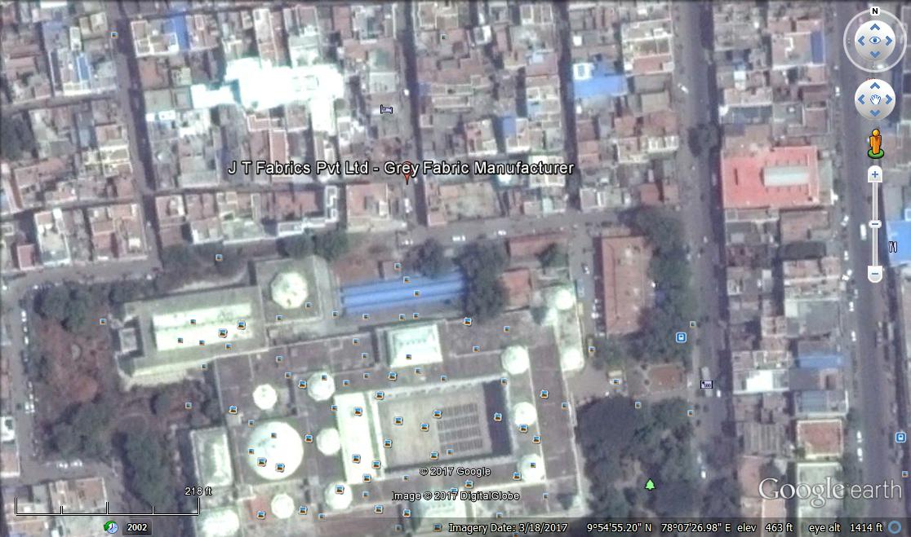

**Physical parameters:**

**Latitude : 9º54¹**

**Longitude : 78º07¹**

**Elevation : 462 Ft**

**SOLAR INSOLATION AT PROPOSED SITE**

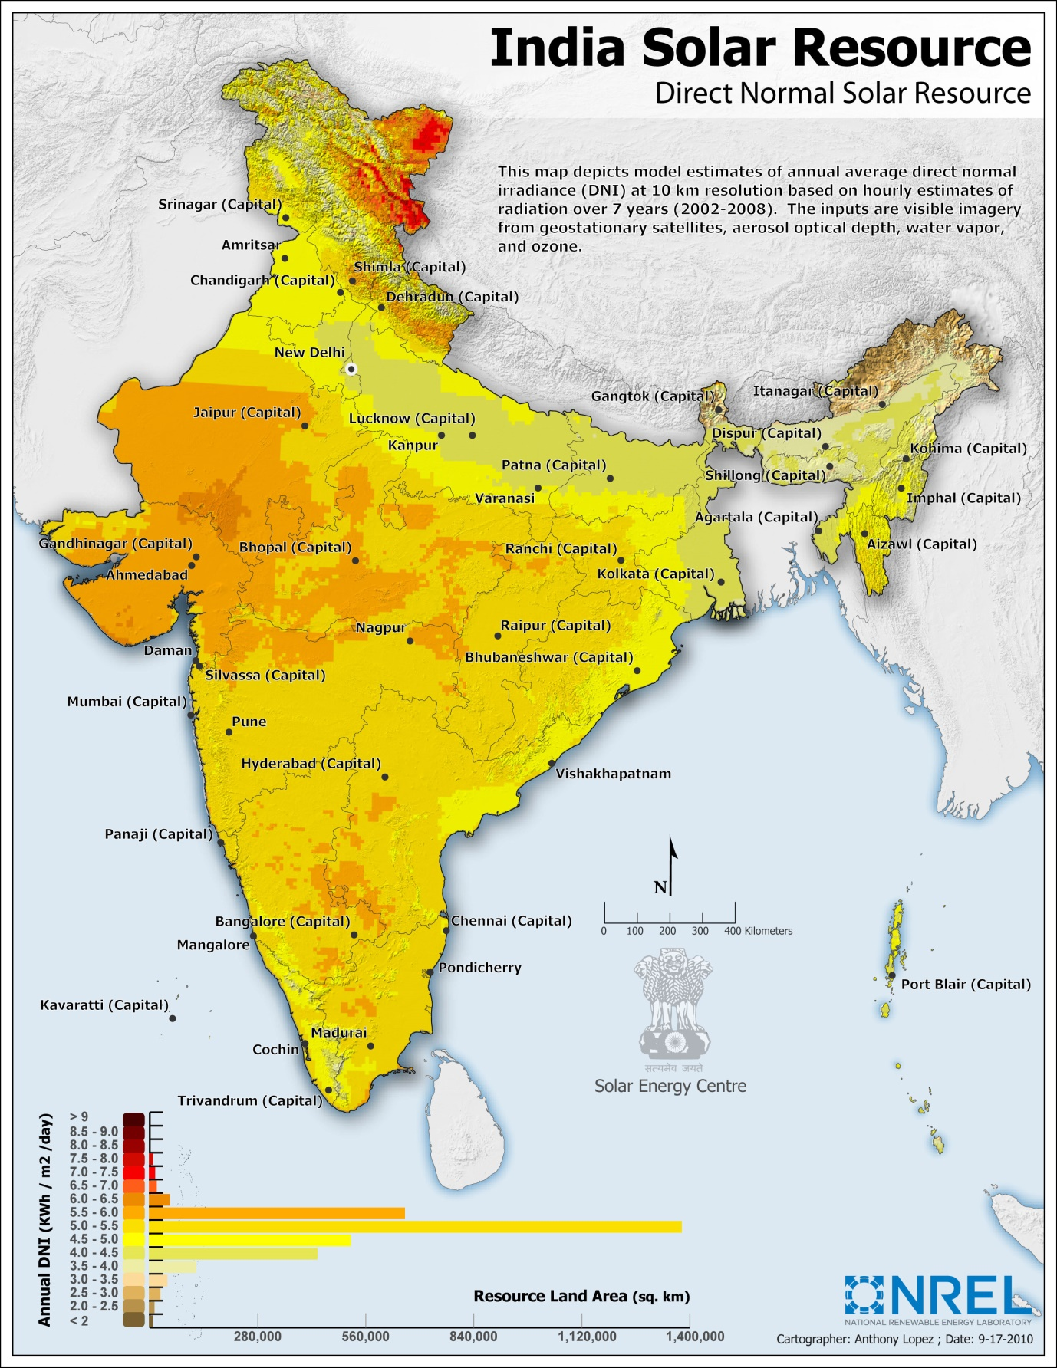

|  |  |
| --- | --- |
| **DNI** | **DIRECT NORMAL IRRADIANCE** |
| **LATTITUDE:** | **9°54¹** |
| **LONGITUDE:** | **78°07¹** |
| **ELEVATION:** | **462 Ft** |
| **CLIENT** | **J.T. FABRICS Pvt. Ltd.** |
| **MONTH** | **SOLAR INSOLATION KWh/Sq.M/DAY** |
| **JANUARY** | **3.22789990234** |
| **FEBRUARY** | **5.05600000000** |
| **MARCH** | **6.39170019531** |
| **APRIL** | **5.74810009766** |
| **MAY** | **5.35570019531** |
| **JUNE** | **4.16389990234** |
| **JULY** | **2.96310009766** |
| **AUGUST** | **3.71230004883** |
| **SEPTEMBER** | **4.89529980469** |
| **OCTOBER** | **4.27729980469** |
| **NOVEMBER** | **3.53030004883** |
| **DECEMBER** | **3.15530004883** |
| **ANNUAL DNI** | **4.36560009766** |

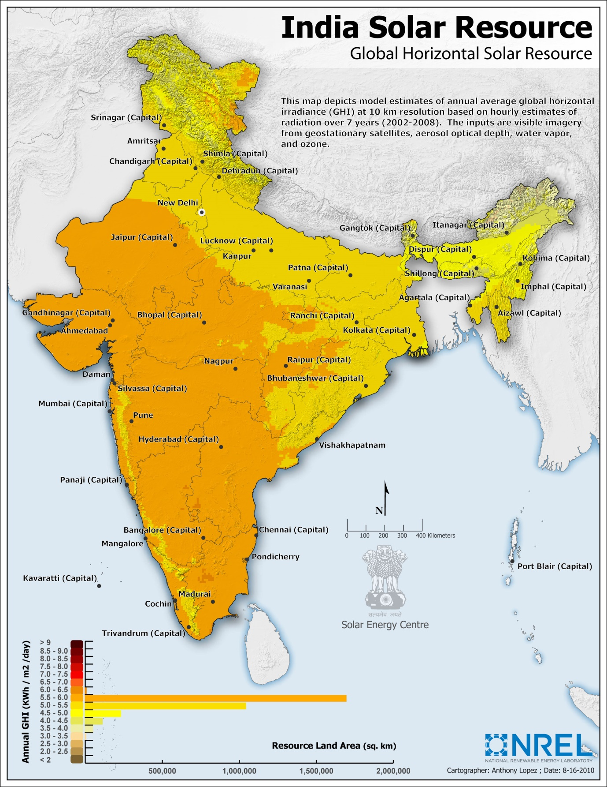

|  |  |
| --- | --- |
| **GHI** | **GLOBAL HORIZONTAL IRRADIANCE** |
| **LATTITUDE:** | **9°54¹** |
| **LONGITUDE:** | **78°07¹** |
| **ELEVATION:** | **462 Ft** |
| **CLIENT** | **J.T. FABRICS Pvt. Ltd.** |
| **MONTH** | **SOLAR INSOLATION KWh/Sq.M/DAY** |
| JANUARY | **3.43889990234** |
| FEBRUARY | **4.75610009766** |
| MARCH | **6.09129980469** |
| APRIL | **6.85839990234** |
| MAY | **7.03310009766** |
| JUNE | **6.34389990234** |
| JULY | **5.48470019531** |
| AUGUST | **5.41470019531** |
| SEPTEMBER | **5.45910009766** |
| OCTOBER | **5.00729980469** |
| NOVEMBER | **3.95760009766** |
| DECEMBER | **3.29189990234** |
| **ANNUAL GHI** | **5.26089990234** |

# TECHNICAL DETAILS:

**SOLAR PV PANELS:**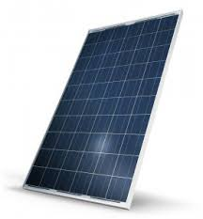

**Make : GREENTEK**

**Model : 325 Wp – 72 Cells**

**RFID : Internal**

**Approvals :MNRE, UL, IEC**

**Warranty : 25 Years**

**Wattage :325Wp**

**Voltage : 46.6 V**

**Current :8.85 A**

**Size : 1961 X 991 X 40 mm**

**Weight : 24 KG**

**CERTIFICATIONS:**

**IEC – 61215, 61730, 62716& UL CERTIFIED**

**MNRE APPROVED**

**Solar Grid – Tied Inverter:**

**Make:Growatt / Delta / Sungrow**

**Model :50 KVA**

**MPP Range :480-850 V**

**Operating Range :200-950 V**

**Min DC Voltage/Starting Voltage:200/250V**

**No-Load Voltage :1000V**

**Maximum input Current :3*36.0A**

**No of MPP Trackers :4**

**Max Power /Tracker :50KW**

**No of strings :3*4**

**Rated Output :49900 VA**

**Supply Voltage :According to requirement**

**Rated Current : 50 A**

**Rated Frequency :50/60Hz**

**Cos Phi :0.80 inductive,capacitive**

**No of Grid Phases :3**

**Protection Class :IP-65**

**Weight :50 Kg**

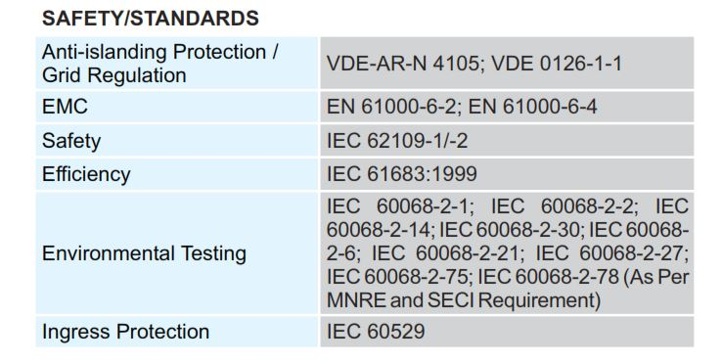

**Mounting Structure:**

**Protection:Galvanized**

**Longevity:Rust proof**

**Material:Mild steel**

**Warranty : 30 years**

[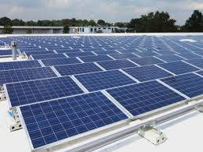](https://www.google.co.in/imgres?imgurl=https://hinrenblog.files.wordpress.com/2015/09/gehrlicher_solar_new_jersey.jpg?w=464&h=348&imgrefurl=http://www.hinren.com/grid-tied-rooftop-solar-pv-system-policies-in-states/&docid=EEEWcgK3aSxsqM&tbnid=2qPKkqEYJs-W5M:&w=464&h=349&hl=en&bih=651&biw=1366&ved=0ahUKEwiE4tiStqLOAhUGo5QKHYCWD2kQxiAIAg&iact=c&ictx=1)

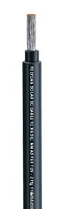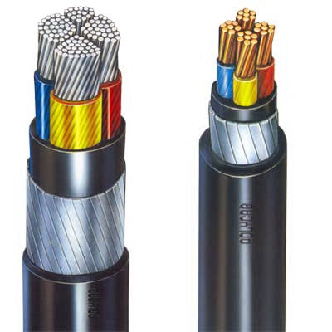**Cables:**

**Polycab**

**UV Resistant**

**Type 1 cable**

**ISO 9001:2008 and 14001:2004 certified**

**Flame Retardant Low Smoke**

**High temperature resistant (Up to 1200C)**

**Tasks and Scope of work:**

|  |  |  |
| --- | --- | --- |
| **TASK DESCRIPTION** | **SCOPE** | |
| **PRE-CONTRACT STAGE REMARKS** | | |
| **AGREEMENT** | **CLIENT&GREENTEK** |  |
| **GATHER REQUIREMENTS** | **GREENTEK** |  |
| **SITE SURVEY** | **GREENTEK** |  |
| **PROJECT PROPOSAL** | **GREENTEK** |  |
| **FEASIBILITY REPORT** | **DISCOM** |  |
| **EXECUTION STAGE** | | |
| **DESIGN – Civil, Electrical and Mechanical** | **GREENTEK** |  |
| **SOURCE ALL COMPONENTS** | **GREENTEK** |  |
| **CIVIL WORKS** | **GREENTEK** |  |
| **MOUNTING STRUCTURE’S ERECTION** | **GREENTEK** |  |
| **PV MODULE MOUNTING** | **GREENTEK** |  |
| **DC WIRING FROM PV MODULES TO INVERTER & TERMINATION** | **GREENTEK** |  |
| **AC WIRING FROM SOLAR INV. TO LOADS& TERMINATION** | **GREENTEK** |  |
| **EARTHLING & LIGHTINING ARRESTORS** | **GREENTEK** |  |
| **COMMISSIONING** | **GREENTEK** |  |
| **POST-EXECUTION STAGE** | | |
| **TRIAL RUN** | **GREENTEK** |  |
| **INSPECTION** | **DISCOM** |  |
| **GRID SYNCHRONISATION** | **DISCOM** |  |
| **TRAINING CLIENT PERSONNEL** | **GG Enterprises** |  |
| **SUBMISSION OF MANUALS & WARRANTIES** | **GG Enterprises** |  |
| **HANDING OVER** | **GREENTEK &**  **GG Enterprises** |  |
| **OPERATIONS& MAINTENANCE** | **GG Enterprises** |  |

**Financials:**

|  |  |
| --- | --- |
| **Cost of the project** | **INR. 63,08,000/-** |
| **Taxes (VAT-5%)** | **INR. 3,15,400/-** |
| **SECI SUBSIDY 30%** | **NA** |
| **NET PAYABLE BY CUSTOMER** | **INR. 66,23,400/-** |
| **Depreciation Claim @ 30%** | **INR. 19,87,020/-** |
| **Actual Investment on System** | **INR. 46,36,000/-** |
| **Transportation to Site** | **Inclusive** |
| **Cost of Grid Synchronization** | **INR. 1,00,000/-** |
| **Cost of Bi-Directional meter** | **At actual** |

**(Rupees: Sixty Six lakhs Twenty three thousand four Hundred only)**

**Note:**

1. **Cost of Liasoning with DISCOM, MNREfor getting approvals and processing fee will be INR. 1,00,000/-.**
2. **Subsidy 30% applicable only to Educational Institutions, Hospitals, Residential and nonprofit making organizations (Trusts and Societies).**
3. **Total plant insurance – Customer scope.**
4. **AMC free for first 2 years.**

**Payment Terms:**

|  |  |
| --- | --- |
| **Advance along with PO** | **30%** |
| **After getting DISCOM feasibility** | **50%** |
| **Before the dispatch of material** | **10%** |
| **Upon commissioning** | **10%** |

**Warranty:**

|  |  |
| --- | --- |
| **Solar PV module Performance warranty** | **25 years** |
| **Grid tied Inverter** | **5 years** |

**Key Features of the Plant:**

|  |  |
| --- | --- |
| **Expected Power Generation from 97 KW solar power plant per day @ 5Kwh / KW** | **485Units** |
| **Net Export to the Grid (Month)** | **14,550Units** |
| **Net Generation Cost@Rs. 7.5(Monthly)** | **INR 1,09,125-00** |
| **Peak Generation cost per year considering 320 days working** | **INR 11,64,000-00** |

**CASH FLOW – ANALYSIS FOR 97 KW SOLAR PV PLANT:**

|  |  |  |  |  |  |  |
| --- | --- | --- | --- | --- | --- | --- |
| **YEAR** | **GENERATED UNITS** | **TARIFF** | **SAVING** | **CUMULATIVE SAVINGS** | **Cum Int on Surplus** | **TOTAL SAVING** |
| **1** | **155200** | **7.5** | **1164000** | **1164000** | **0.00** | **1164000** |
| **2** | **154424** | **7.875** | **1216089** | **2380089** | **81480.00** | **2461569** |
| **3** | **153651.88** | **8.375** | **1286834.495** | **3666923.495** | **172309.83** | **3839233.325** |
| **4** | **152883.6206** | **8.875** | **1356842.133** | **5023765.628** | **268746.33** | **5292511.961** |
| **5** | **152119.2025** | **9.375** | **1426117.523** | **6449883.151** | **370475.84** | **6820358.988** |
| **6** | **151358.6065** | **9.875** | **1494666.239** | **7944549.39** | **477425.13** | **8421974.519** |
| **7** | **150601.8135** | **10.375** | **1562493.815** | **9507043.205** | **589538.22** | **10096581.42** |
| **8** | **149848.8044** | **10.875** | **1629605.748** | **11136648.95** | **706760.70** | **11843409.65** |
| **9** | **149099.5604** | **11.375** | **1696007.499** | **12832656.45** | **829038.68** | **13661695.13** |
| **10** | **148354.0626** | **11.875** | **1761704.493** | **14594360.94** | **956318.66** | **15550679.6** |
| **11** | **147612.2922** | **12.375** | **1826702.117** | **16421063.06** | **1088547.57** | **17509610.63** |
| **12** | **146874.2308** | **12.875** | **1891005.721** | **18312068.78** | **1225672.74** | **19537741.53** |
| **13** | **146139.8596** | **13.375** | **1954620.623** | **20266689.41** | **1367641.91** | **21634331.31** |
| **14** | **145409.1603** | **13.875** | **2017552.1** | **22284241.5** | **1514403.19** | **23798644.7** |
| **15** | **144682.1145** | **14.375** | **2079805.396** | **24364046.9** | **1665905.13** | **26029952.03** |
| **16** | **143958.704** | **14.875** | **2141385.721** | **26505432.62** | **1822096.64** | **28327529.26** |
| **17** | **143238.9104** | **15.375** | **2202298.248** | **28707730.87** | **1982927.05** | **30690657.92** |
| **18** | **142522.7159** | **15.875** | **2262548.115** | **30970278.99** | **2148346.05** | **33118625.04** |
| **19** | **141810.1023** | **16.375** | **2322140.425** | **33292419.41** | **2318303.75** | **35610723.16** |
| **20** | **141101.0518** | **16.875** | **2381080.249** | **35673499.66** | **2492750.62** | **38166250.28** |
| **21** | **140395.5465** | **17.375** | **2439372.621** | **38112872.28** | **2671637.52** | **40784509.8** |
| **22** | **139693.5688** | **17.875** | **2497022.542** | **40609894.82** | **2854915.69** | **43464810.51** |
| **23** | **138995.101** | **18.375** | **2554034.98** | **43163929.8** | **3042536.74** | **46206466.54** |
| **24** | **138300.1255** | **18.875** | **2610414.868** | **45774344.67** | **3234452.66** | **49008797.33** |
| **25** | **137608.6248** | **19.375** | **2666167.106** | **48440511.78** | **3430615.81** | **51871127.59** |
|  |  |  | **0** | **48440511.78** | **3630978.93** | **52071490.71** |
|  |  |  |  |  | **TOTAL SAVINGS** | **52071490.71** |
|  |  | **ROI (Return on investment)** | |  |  |  |
|  |  | **TOTAL CUMULATIVE SAVING IN 25 YEARS** | | |  |  |
|  | **TARIFF ESCALATION** | **5% per anum** | |  |  |  |
|  | **DETORIATION** | **0.5% Per Year** | |  |  |  |
|  | **INTEREST ON SAVINGS** | **7% Per Anum** | |  |  |  |

**Annual Maintenance Contract (AMC)**

**FREE FOR 2 YEARS**

**SCOPE OF WORK**

***We offer the following services as a part of solar plant annual maintenance contract:***

|  |
| --- |
| **1) Facility Management:**  Maintenance and |
| Implementation of official requirements for technical operation, |
|  |
|  |
| **2) Plant Monitoring:** Monthly analysis and evaluation of operational plant data |
| Remote monitoring |
| Plausibility test of current yield and weather data(If available) |
| Energy meter value management |
| Service Hot line from 8.00 hr-17.00 hr. |
|  |
| **3) Preventive Maintenance:** Preventive inspection and maintenance of system according to |
| Manufacturer’s specifications |
| Documentation of events and measures |
| Provision of small parts and operating material |
| Conduction of regulatory tests according to technical standards |
|  |
| **4) Fault detection and analysis:** Function check after fault message is received |
| Immediate start of fault removal measurers |
| Long term trend analysis |
|  |
| **5) Management of repairs:** Analysis of interruptions and incidents and claims |
| Supply chain management for spare parts i.e. modules, inverters, |
| Cabling and mechanical components |
|  |
| **6) Documentation and Data management:**  Documentation of plant energy output and system availability |
| Electronic plant logbook |
| Detailed information about main events measures |
| Customer reports on a quarterly/yearly basis |
|  |
| **7) Warranty and service management:**  Monitoring and tracking of warranty rights |
| Support with insurance cases |
| Coordination and managing of external (3rd party) service providers (If any) |

**AMC – COST AFTER 2 YEARS**

**OPTION - 1**

**AMC – Service without spares**

|  |  |
| --- | --- |
| **AMC COST FOR 100 KW SOLAR POWER PLANT** | **INR. 45,000-00** |
| **SERVICE TAX @ 18%** | **INR. 8,100-00** |
| **NET PAYABLE** | **INR. 53,100-00** |
| **ESCALATION** | **5% P.A** |

**OPTION – 2:**

**As the solar power plant is maintenance free, as and when there is a problem, our service team will attend within 24 hours to resolve the issue. We will be charging per visit INR. 5,000/- + Tax as service charge per visit. If any part replaced during service, it will be charged extra at actual.**

***With all the attributes of a reliable group, we take the opportunity to approach you for giving us the opportunity to serve you with quality and expertise.***

***Looking forward to receive your valuable order on which we will give our prompt attention for smooth execution***.

**Dr. N.V. VIJAYAPRASAD M.Sc., M.Phil., Ph.D.**

**G M (Projects - R&D)**

**S.SANDHOSH KUMAR**

**Regional Manager – Projects & Sales | South India**

**GREENTEK INDIA Pvt. Ltd.**

**Plot No. 8, Lepakshi Colony, West Marredpally, SECUNDERABAD – 500 026.**

**Telangana., India. Ph: 040-27807145 / 65198519**

**E-mail:** [**southsales@greentekindia.co.in**](mailto:southsales@greentekindia.co.in) **| Web Site: www.greentekindia.co.in**

**Associate Partner (Projects) – Tamil Nadu**

**N. Tamil Manian**

**GG Enterprises**

**Chola Towers, G1, Old No 134, New No 165, Medavakkam Main Road, Adambakkam,Chennai-600 088.Mobile: 9445744359/9840311359**

**E-Mail :** [**ggenterpriseschennai@gmail.com**](mailto:ggenterpriseschennai@gmail.com)



**To:**

**M/S J.T.Fabrics,**

**MADURAI**

**Price Breakup for 97KW On-Grid**

|  |  |  |  |
| --- | --- | --- | --- |
| **S.NO.** | **Description** | **Capacity** | **Price** |
| **1** | **Greentek** make SPV Panel (325 Wp * 298 Nos) | 97 KW | 3,200,000.00 |
| **2** | ON Grid PCU 30 KVA X 3 Nos **Poly cab / equivalent** | 99 kVA | 650,000.00 |
| **3** | Module Mounting Structural Work-GI | 33 kVA x 3 | 480,000.00 |
| **4** | DC DB – **Greentek** | 33 kVA x 3 | 90,000.00 |
| **5** | AC DB – **Greentek** | 33 kVA x 3 | 86,000.00 |
| **6** | D.C Cable **Poly cab / equivalent** |  | 130,000.00 |
| **7** | A.C Cable **Poly cab / equivalent** |  | 40,000.00 |
| **8** | Wiring & Installation |  | 350,000.00 |
| **9** | Electrical materials and others |  | 650,000.00 |
| **10** | Misc |  | 100,000.00 |
| **11** | Transportation |  | 32,000.00 |
| **12** | Others ( Marketing, Auditing & profits) |  | 500,000.00 |
|  | **Sub Total** |  | 6,308,000.00 |
| **GST @ 5%** | | | 315,400.00 |
| **Total** | | | **6,623,400.00** |
| **13** | Liasioning & Discom feasibility Charges |  | 100,000.00 |

**Terms & Conditions**

* Price is valid only for 3 weeks from the date of Quote.

Best Regards,

Sandhosh Kumar

Regional Manager (South India)

Greentek India Pvt Ltd.,